**PAS**

**To:** Dr. Matt Bohm

**From:** PAS

**Project:** Plasma Arc Speaker

**Subject:** Concept Variant 8

**Date:** March 4, 2011

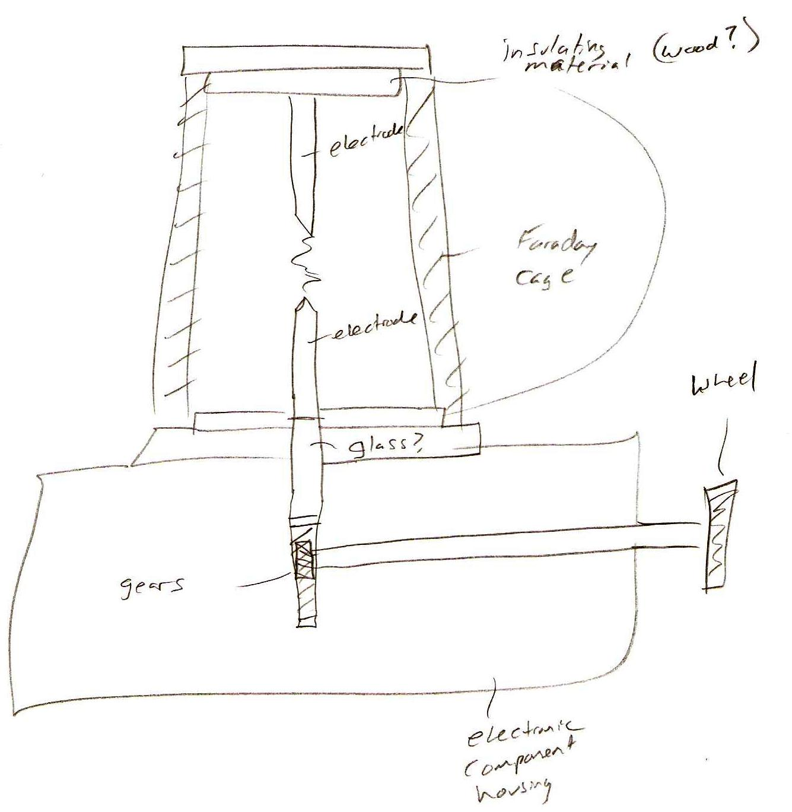

CV 8 consists of an electrical component housing on the bottom.  The electrodes are located vertically above the housing and are insulated with wood or a ceramic material on the top and bottom, as well as being surrounded by a Faraday cage.  The bottom electrode is connected to a geared rack and pinion setup, with the electrode bottom being the rack and the hand wheel connection being the pinion. The device lowers and raises the electrode when turning the hand wheel.